9.SUB QUERIES

1. The HR department needs a query that prompts the user for an employee last name. The query then displays the last name and hire date of any employee in the same department as the employee whose name they supply (excluding that employee). For example, if the user enters Zlotkey, find all employees who work with Zlotkey (excluding Zlotkey).

Ans: SELECT LASTNAME, HIREDATE

FROM employees

WHERE DEPARTMENT_ID = (

SELECT DEPARTMENT_ID

FROM employees

WHERE LASTNAME = :enter_last_name

)

AND LASTNAME <> :enter_last_name;

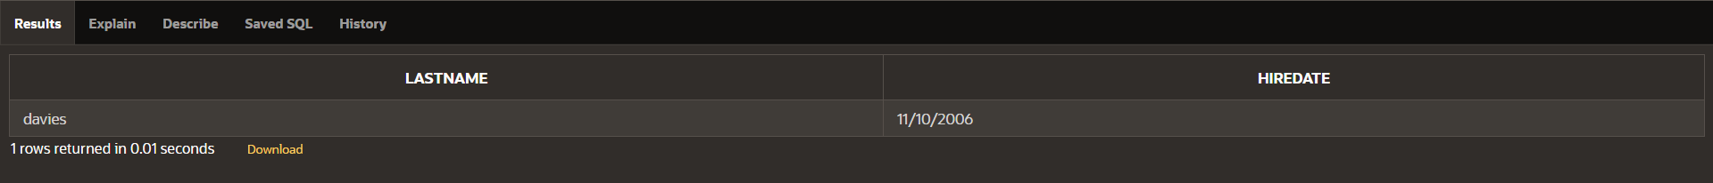

2. Create a report that displays the employee number, last name, and salary of all employees who earn more than the average salary. Sort the results in order of ascending salary.

Ans: select employee_id,lastname,salary from employees where salary > (select avg(salary) from employees) order by salary asc;

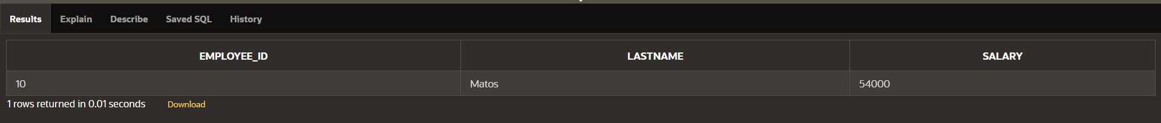

3. Write a query that displays the employee number and last name of all employees who work in a department with any employee whose last name contains a u.

Ans: SELECT employee_id, lastname

FROM employees

WHERE department_id IN (SELECT department_id

FROM employees

WHERE lastname LIKE '%u%');



4. The HR department needs a report that displays the last name, department number, and job ID of all employees whose department location ID is 1700.

Ans: select lastname, department_id,job_id

from employees

where department_id = (select department_id

from employees

where country_id = 1700);

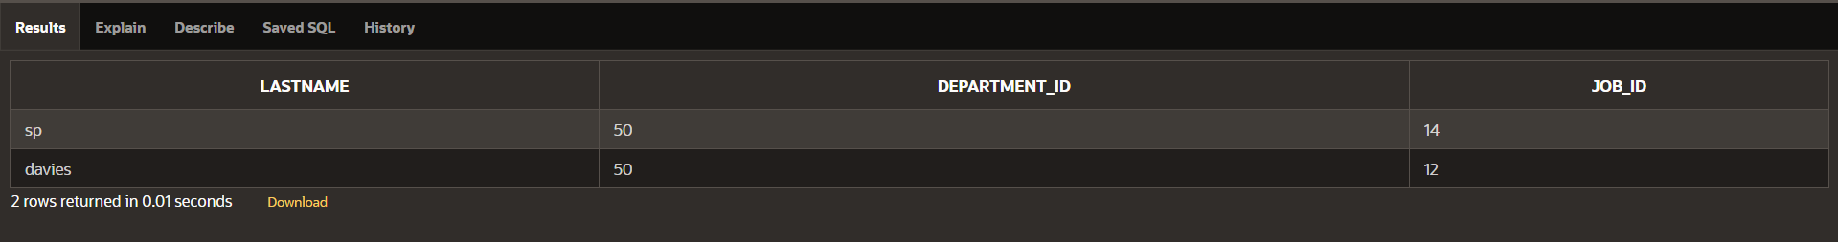

5. Create a report for HR that displays the last name and salary of every employee who reports to King.

Ans: SELECT lastname, salary

FROM employees

WHERE manager_id = (SELECT employee_id

FROM employees

WHERE lastname = 'King');



6. Create a report for HR that displays the department number, last name, and job ID for every employee in the Executive department.

Ans: SELECT department_id, lastname, job_id

FROM employees

WHERE department_id = (SELECT departmentid

FROM department_1

WHERE jobc = 'Executive');



7. Modify the query 3 to display the employee number, last name, and salary of all employees who earn more than the average salary and who work in a department with any employee whose last name contains a u.

Ans: SELECT EMPLOYEE_ID, LASTNAME, SALARY

FROM employees

WHERE SALARY > (

SELECT AVG(SALARY) FROM employees

)

AND DEPARTMENT_ID IN (

SELECT DISTINCT DEPARTMENT_ID

FROM employees

WHERE LASTNAME LIKE '%u%'

);

